IMPORTANT:
A solid and stable internet connection is required to ensure your application is submitted correctly.
Effective February 28, 2022, the ACAP submission process is going electronic. The Bureau will not accept any paper submissions for reimbursements.
The Apprenticeship Completion Award Program (ACAP) reimburses the sponsor or apprentice 25% of the related instruction tuition costs or $1,000, whichever is less, associated with a Wisconsin apprentice contract.
To facilitate repayment, maintain related instruction tuition payment records throughout the apprenticeship term.

ACAP funds are awarded on a first-come, first-served basis. Applications may be denied if insufficient funding in a given fiscal year. Awards will not be made if the apprentice associated with the contract is delinquent on child support payments unless a suitable repayment plan is in place.

- On the sBASERS home page, as an authorized user, you will enter your Username and Password to log in:
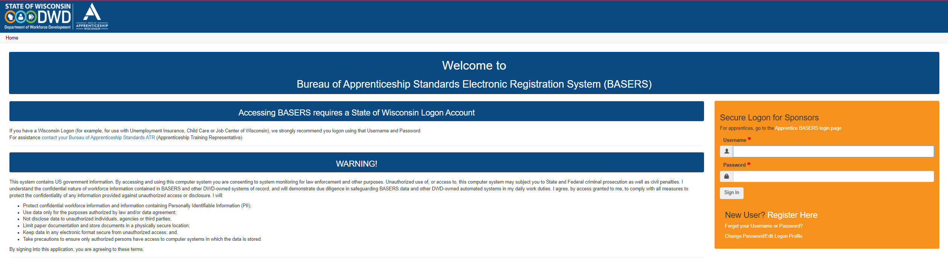

- Once you are logged in, you are taken to the Welcome page:
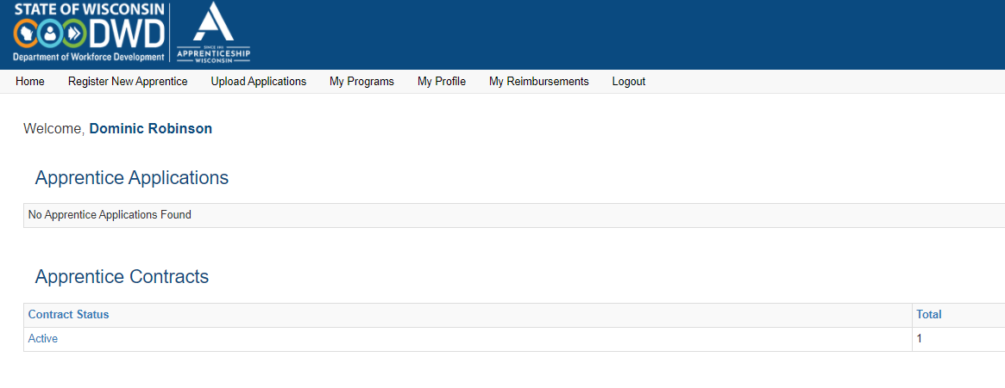
IMPORTANT:

Before you begin to request your reimbursement, you must have the correct FEIN number associated with your business or organization. This will help our financial department ensure that the correct entity receives the payment.

To enter or update the FEIN number, go to the "My Profile" tab:
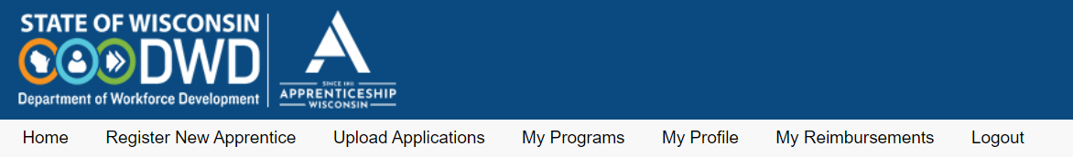

Scroll down to where you will see the "Link to Current Sponsor Detail" (Hint: it's right under the "Save" button):

Click on the highlighted area "Sponsor Detail" link. This will take you to the Sponsor Details Page, where you will be able to request an update of your FEIN.

To enter or update your FEIN, enter in the FEIN that is associated with your business or organization in the text box:
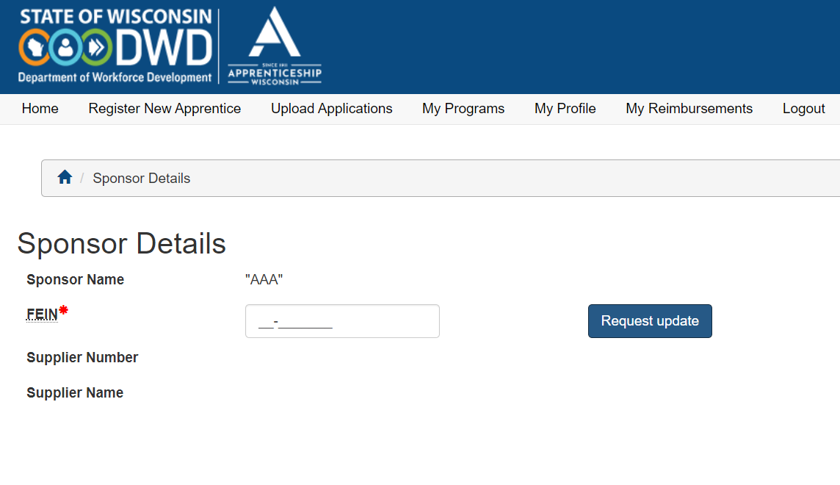

Click on the "Request update" button:

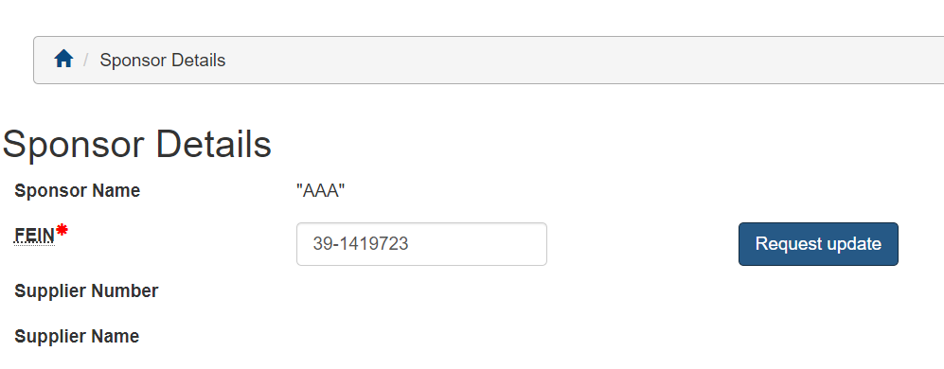

You will receive a notification that the FEIN request has been submitted:
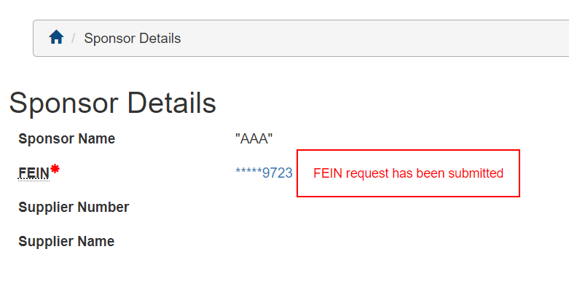

This submission generates a tickler in our BASIS database that will be checked in a timely fashion. Your request will be approved or denied within 2-3 business days from the date it was submitted.

- On the Home page, you will go to the "Active" or "Completed" link under the "Apprentice Contracts" section to request an ACAP reimbursement:
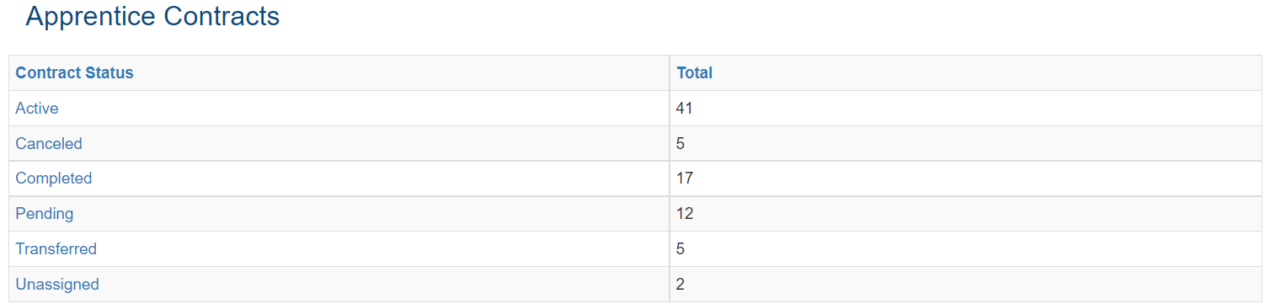

- To begin the reimbursement request, you will have to verify the apprentice's personal information by selecting one of the two options:

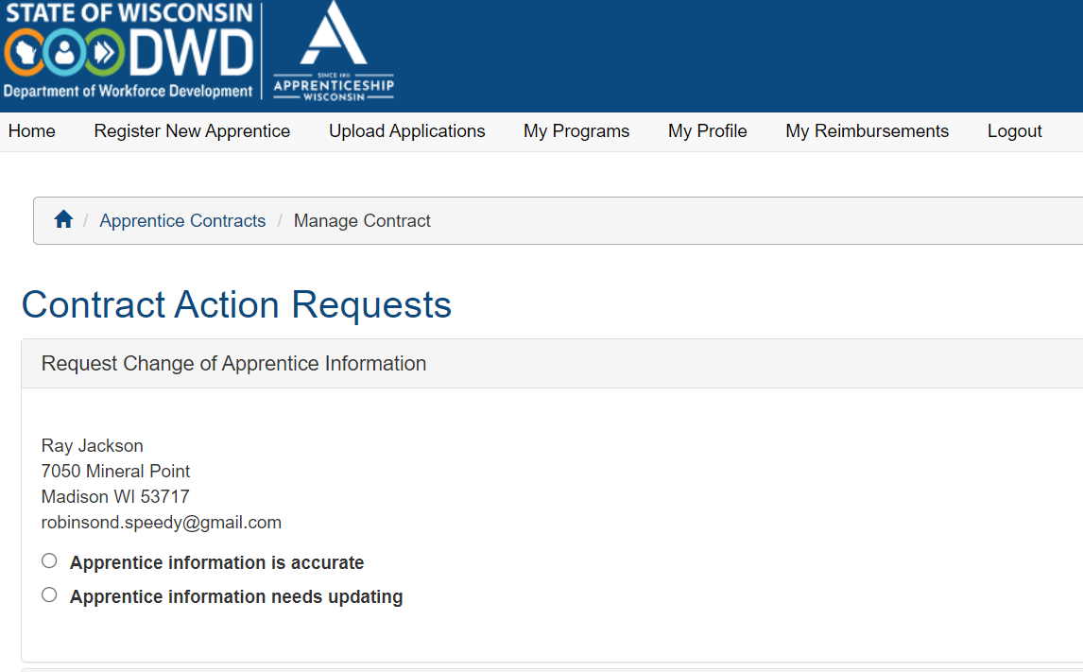

- This will generate a tickler that will be viewed and updated by the ATR. You will still be able to submit the reimbursement request without waiting for the ATR to approve this tickler.

- As soon as you verify the apprentice's personal information, you will scroll down and click on the "Request Reimbursement" link to see what type of reimbursement you are eligible for.
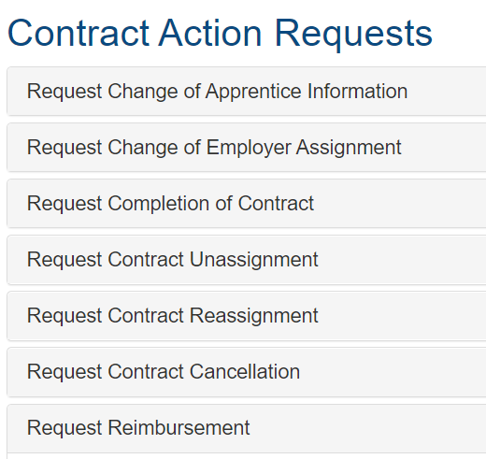

- Select ACAP for your reimbursement request:

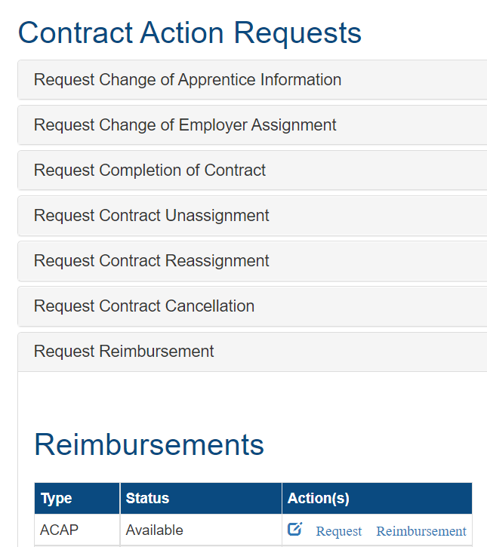

- You will then select the location where you want the check to be sent to:
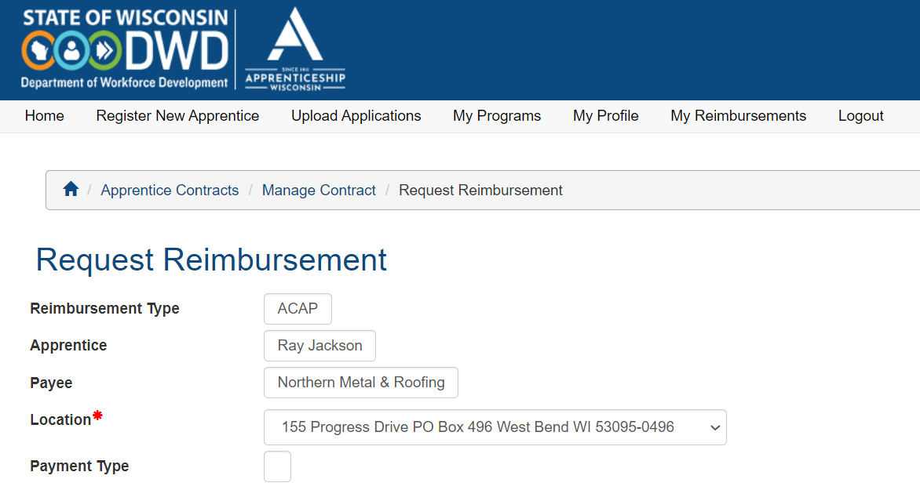
- Click the box that states that you agree that the information you provided is accurate and complete:

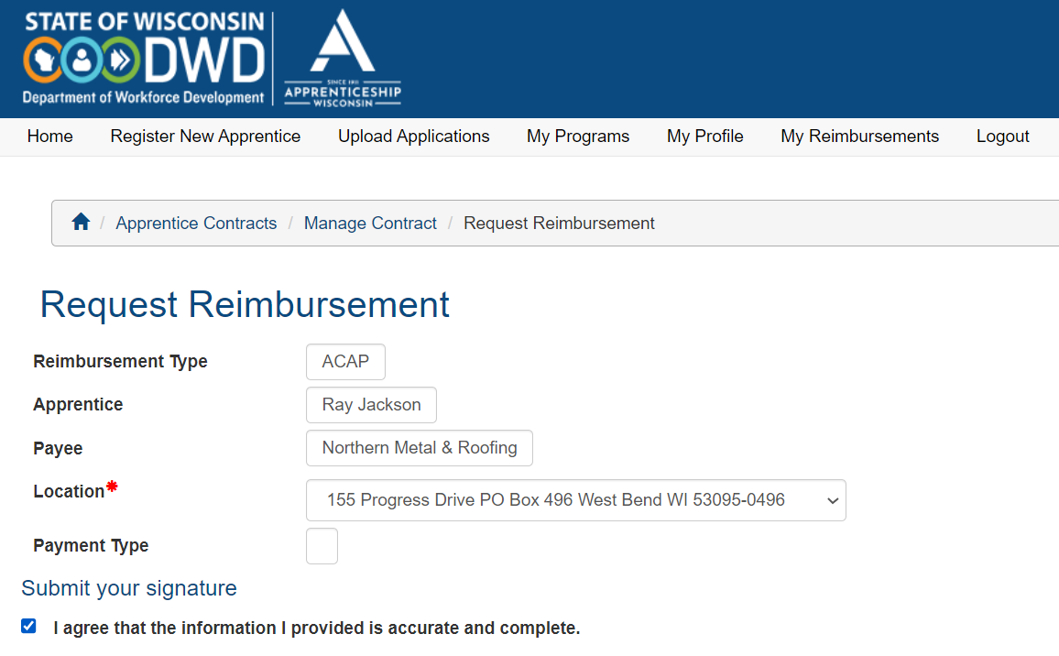

- Type in your name as your Signature and Legal Name:
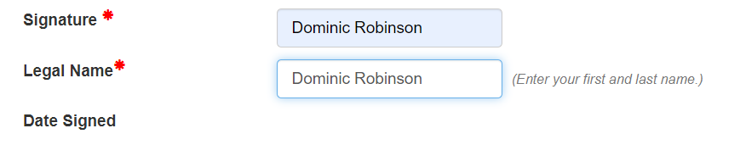

- Click on the Save button;

- Once saved, you can now submit proof of tuition payment.

IMPORTANT:
Remember, the following are considered acceptable proof of payment:

  - A zero-balance invoice showing payment received
  - A bill showing the previous balance paid will cover the previous balance
  - A canceled check showing both front and back that matches invoice (please black out account number)
  - An invoice marked paid by the company receiving payment Wire transfer documentation (please blackout account number)
  - Receipt showing payment (Examples: Cash receipt, an online receipt showing credit card payment)
  - A letter from the payee confirming the account has been paid, referencing the total amount and invoice number
  - Credit card statement showing purchase amount and vendor information (please blackout account number)
  - Image of the original check with check number, accompanied by a bank statement showing check number clearing (please blackout account numbers)

- Click on the add cost item button to begin to submit your proof of payment:

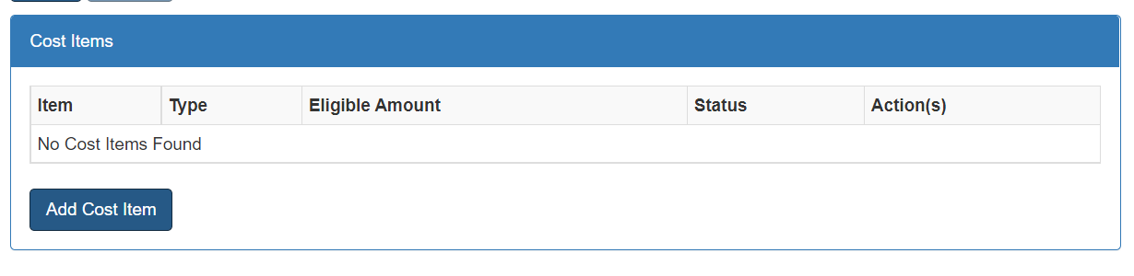

- Clicking this button takes you to the Item Cost page. The Item Type will reflect if you are requesting reimbursement for Year One or Completion:

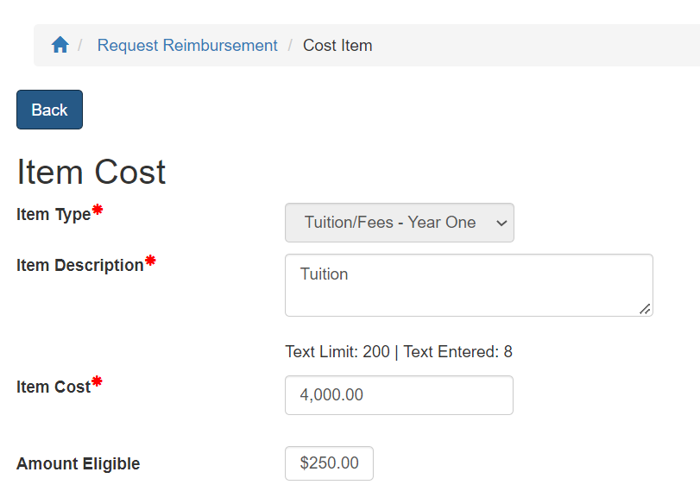

- Type in Tuition Reimbursement in the Item Description box on this page:

- After entering in the Item Description, you will enter the amount you paid for tuition in the Item Cost text box:

- The system will then calculate how much you are eligible to receive:

- Click on the Save button to save your entry:

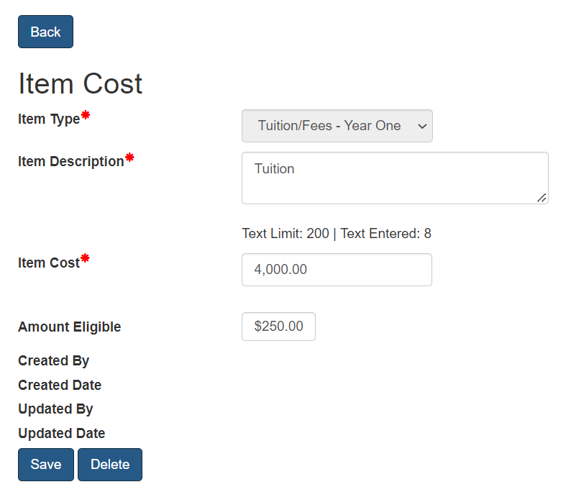

- After clicking on the Save button, you will now enter your receipts by typing in the receipt name in the text box:

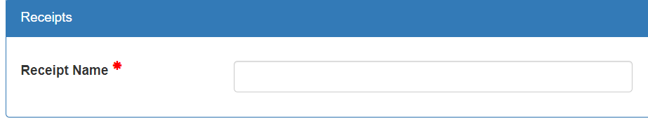

- This will allow you to upload your proof of tuition payment.

- To choose the file that you have saved your payment records, click the Choose File button:
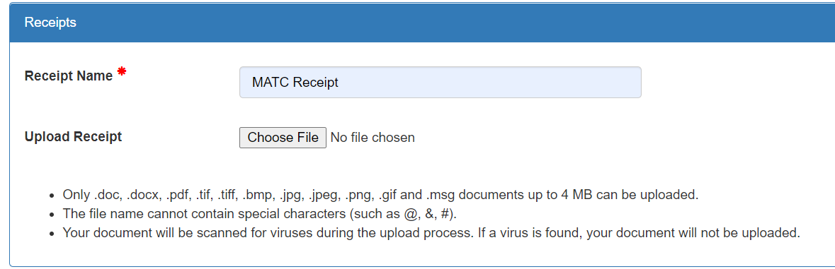

- Select the file that shows the proof of payment. It will upload into the system:
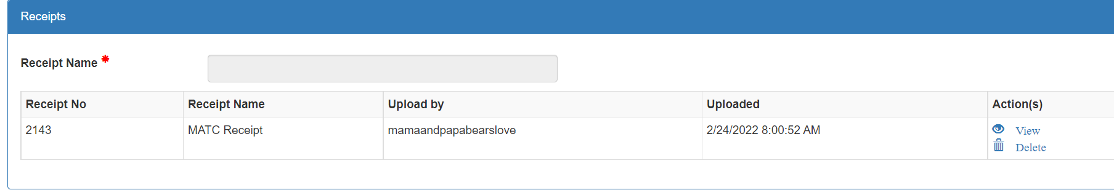

- You can view or delete the proof of payment by selecting View or Delete in the Actions column:
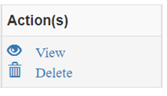

Note: If you feel like you have entered this in error, you can click on the Delete button to delete the entry:
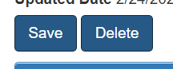

- After uploading your proof of payment, you will now go to the top of the screen and click on the Back button:
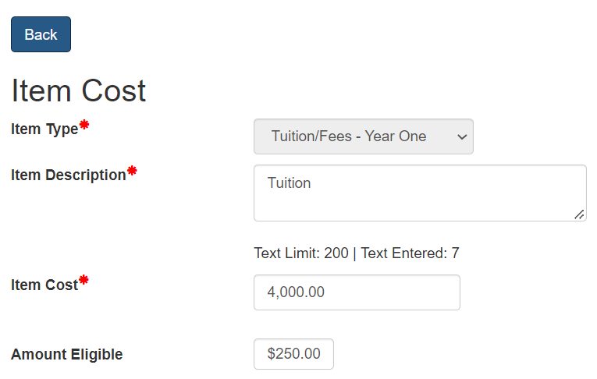

- This will take you back to the Request Reimbursement Page, where you can add another cost item, if needed, by clicking on the Add Cost Item button and following the steps outlined previously.

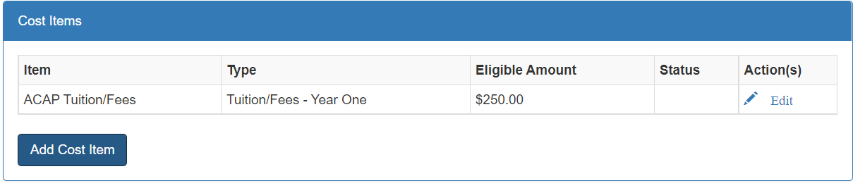

- When you are finished adding all your cost items, click on the Submit button to submit the reimbursement request:

