Accessing and Running Business Objects Reports in BI Launch Pad

- Logging In
- BI Launch Pad Home Page
- Accessing/Managing Reports
- Viewing/Opening Reports
- Refreshing Reports
- Navigating Within Reports
- Searching in Reports
- Hyperlinks
- Drilling, Filtering, and Input Controls
- Outline Mode
- Saving/Exporting/Printing Reports
- Additional Information

Logging In

To log in to BI Launch Pad to access reports:

- Navigate to the YA homepage (www.ya.wi.gov) and click on YA Coordinator

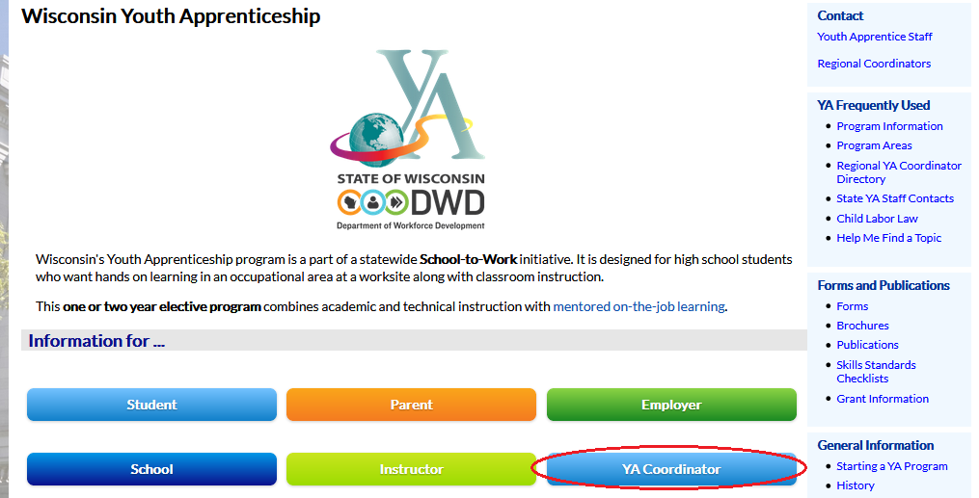

- Click on Online Student Registration

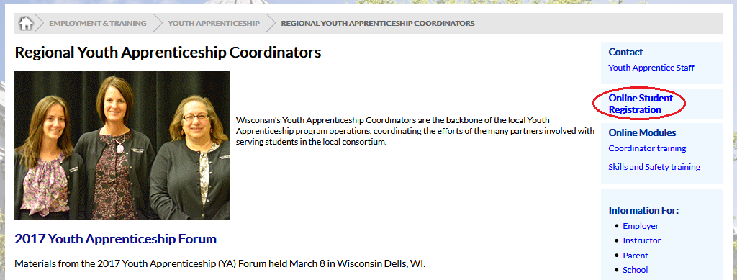

- Click on the DWD BI Portal link

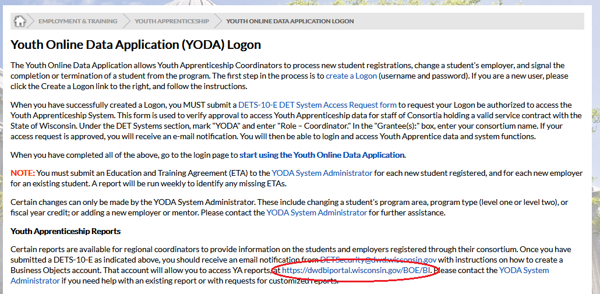

- Enter your Logon ID (Username) and password. For Authentication, choose Windows AD if you are a DWD employee or Enterprise if you are an external user. Then click the Log On button.

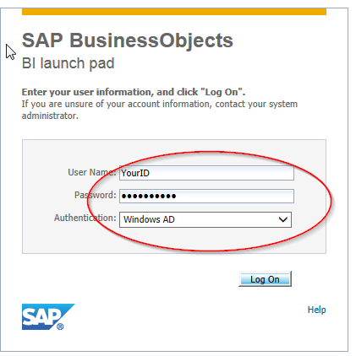

BI Launch Pad Home Page
The BI launch Pad is the portal for accessing and viewing reports. Note the tabs in the upper left corner which allow you to navigate within the portal. By default, the Launch Pad opens to the Home page.

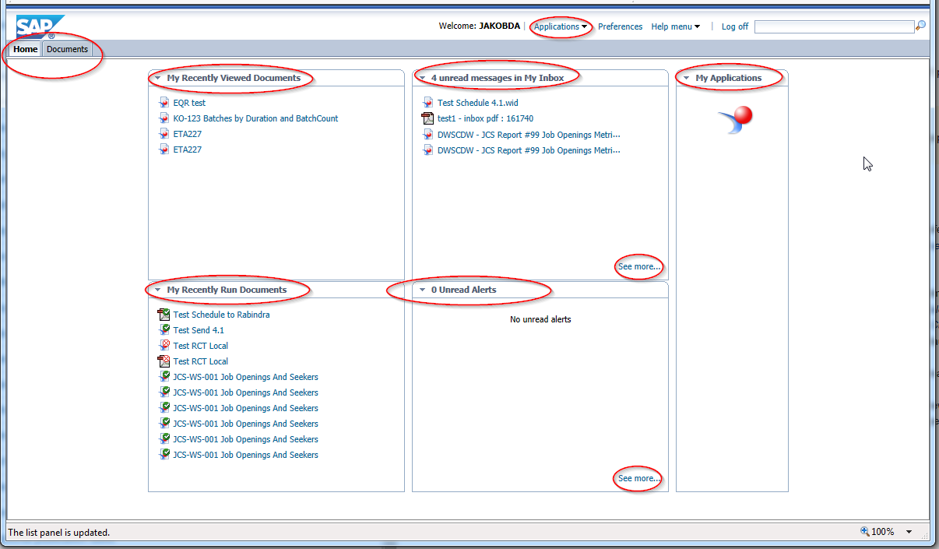

The home page displays:
- My Recently Viewed Documents - This allows you to open recently viewed documents directly from the Home page. Nice if you access the same reports often
- My Recently Run Documents - These are documents that you have scheduled. Selecting a document will open the specific scheduled instance of the document.
- Unread Messages in My Inbox - This will display documents in you inbox that you have not yet opened. Clicking See More … will take you to the BI inbox itself to see all items in your Inbox
- Unread Alerts - As with the Inbox panel, This will display any unread alerts you are set up to receive and clicking See More … will show all alerts. We are currently not implementing any alerts.
- My Applications - This allows you to launch other SAP BI applications which you are authorized to use. Note that there is also a dropdown in the title bar for Applications

Accessing/Managing Reports
To browse documents, click the Documents tab (upper left)

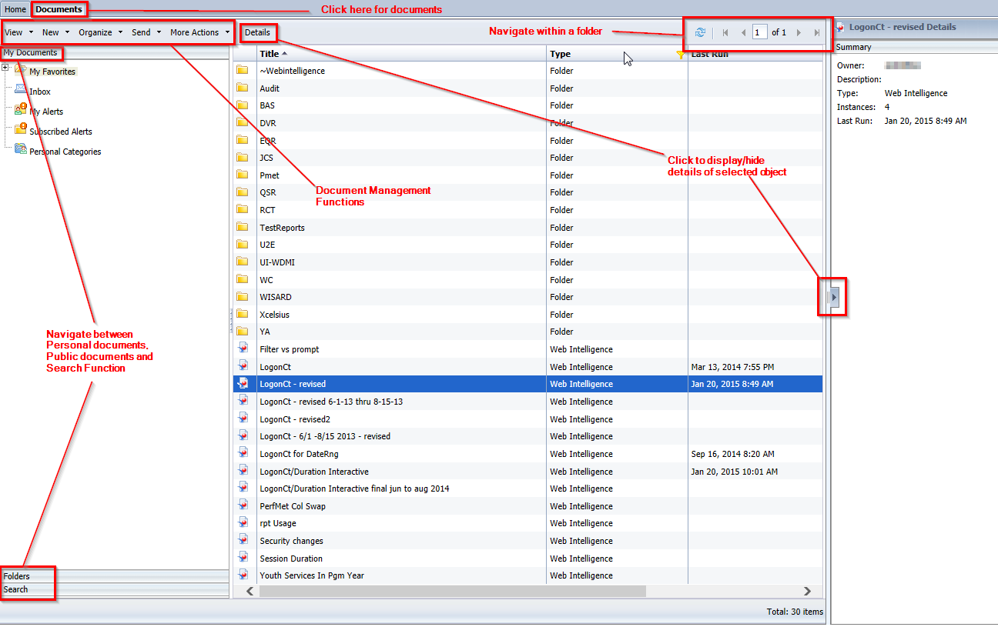

The documents tab is much like Windows Explorer, with a navigation tree on the left and a display of the selected folder's contents. Navigation within a folder can be done with paging arrows or entering a page number in the upper left where there is also a Refresh button to refresh the folder view.

The left navigation panel has navigation bars (click to select) across the panel to separate:
- My Documents – A user's personal Inbox and Favorites folders, along with their personal alerts and categories (not used at this time). By default, the My Documents bar is selected when you navigate to the Documents tab.
- Folders – Public folders a user has permission to access
- Search – Search function which allows you to search for objects (reports/folders) matching a specific text pattern. All results matching the pattern are displayed in the list pane along with selections in the search pane allowing you to refine your search (see below under 'Searching for a document')
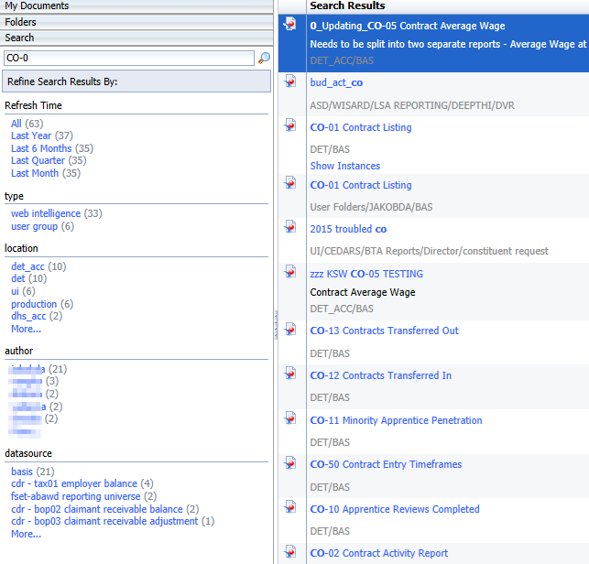

To view/hide details of the selected object, click the Details button on the menu bar or the arrow on the left of the list window.

Document and Launchpad management functions are in the menu bar across the top.

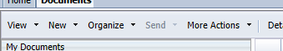

Users will have selections available (visible and not greyed out) based on permissions that they have been assigned and objects selected in the navigation and list panes. The images below display the functions/actions available under each of the dropdown menus.
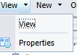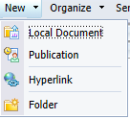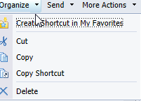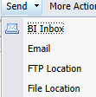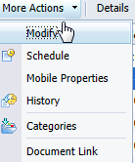

These are also available by selecting an item and right-clicking to display a popup menu of applicable menu items.
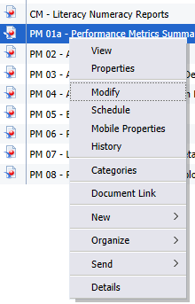

Viewing/Opening Reports
To open and view a report, either double-click on the report or select it and use the View or Right-Click menu and select View. The report will open in a new tab in the portal (note that each report opens in a new tab and you can have multiple reports opened simultaneously). Some reports are set to refresh when opened. See next section on refreshing reports.

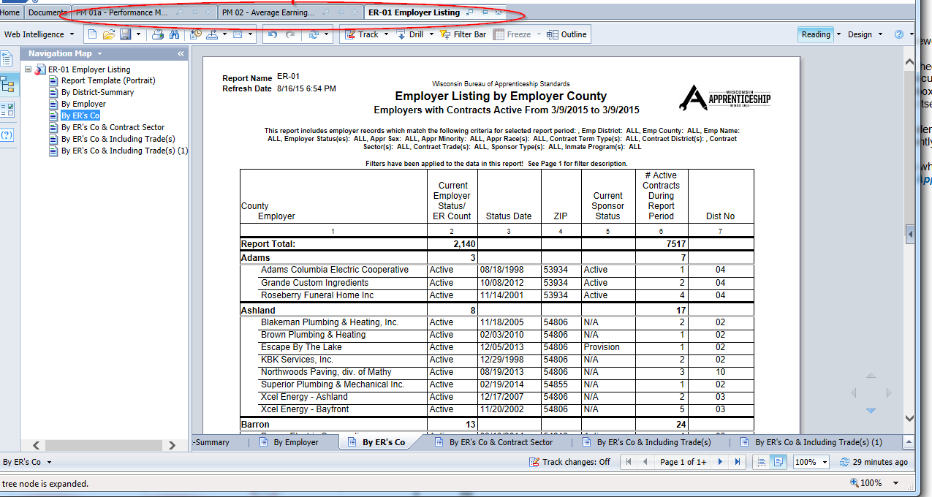

Refreshing Reports
Many reports are set to refresh when opened and will display the Prompts window for the user to enter report parameters.

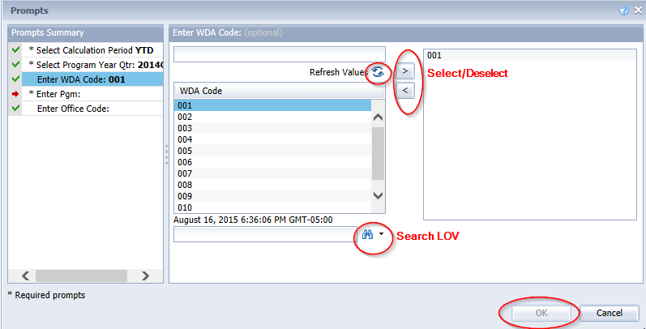

Prompts with an asterisk (*) are required and values must be selected/entered to refresh the report. Enter or select a value and use the select/deselect arrows. If no values are shown in the list, click the Refresh button. Once all (required) values are entered the OK button will be enabled. To refresh the report, Click OK.

Once a report is opened it can be refreshed one of 2 ways:

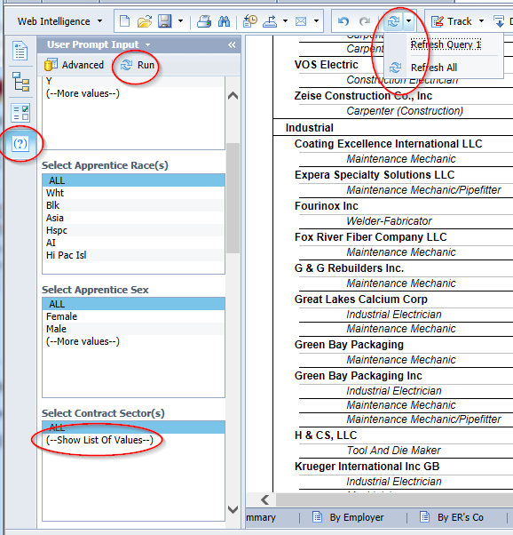

Clicking on the User Prompt Input icon on the left will display the user prompts in the left panel where parameter values are selected and Run is clicked. If value lists are empty click Show List of Values.

You can also click the Refresh icon on the menu bar to refresh all queries in the report or the dropdown arrow next to it to refresh in individual query. This will open the Prompts window described in the beginning of this section

Navigating Within Reports
After entering prompt values (or just selecting the report to view if it has no prompts) the report will display.

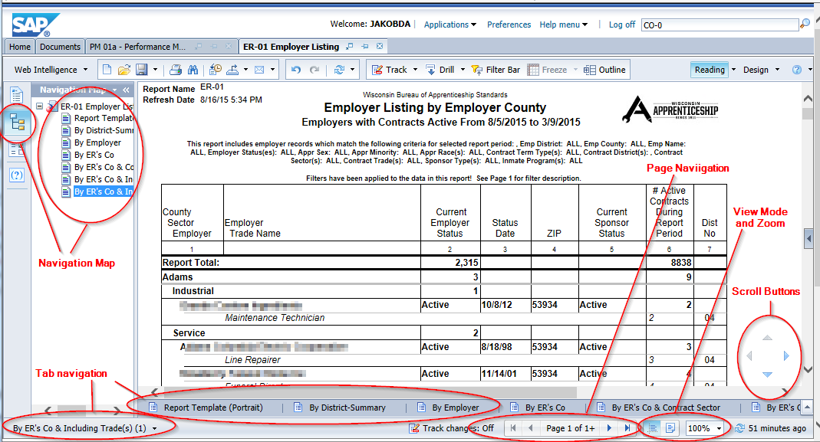

Many reports will have multiple tabs within the report showing different data or alternate/similar views of the same data.
- Tab navigation – Click directly on a tab or expand the tab list and click desired tab
- Navigation map – Click this Icon to display an expandable navigation map showing reports tabs and sections in each tab
- Page navigation – Page forward/backward or got the beginning or end of the document
- View mode and Zoom- Switch between Page mode (displays format when printed) and Quick Display mode (no page breaks or sizing) or set zoom level.
- Scroll buttons – scroll up/down left/right

Searching in Reports
Reports can be searched to find text, for example, a specific individual or ID. To search, click the 'Search Binoculars' icon on the top menu bar and enter your search string (and select other options) in the Search Bar and click the binoculars icon or Find Next/Find Previous.

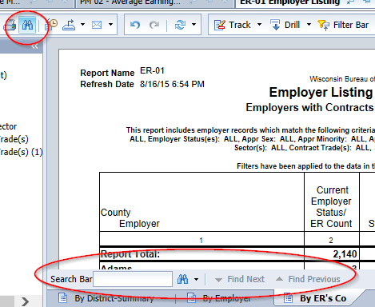

Hyperlinks

Some reports may contain hyperlinks to other Business Objects reports, files, or websites. These will be display as underlined text and will display a 'hand' icon and possibly some information about the link when hovered over. Simply click to navigate to the hyperlinked report will open.

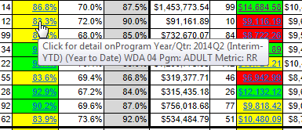

Drilling, Filtering, and Input Controls

Some report tabs may contain interactive features to allow drilling and filtering of the data within a report.

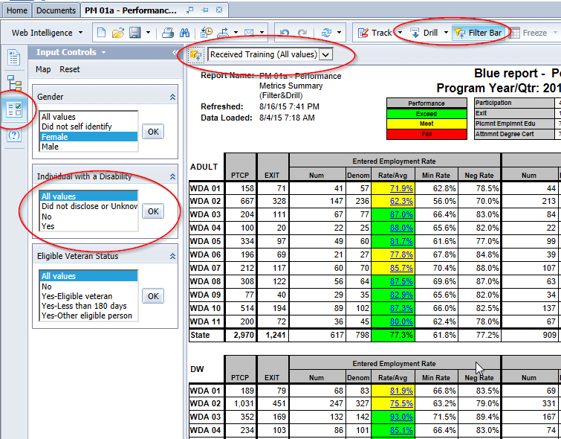.

- Input Controls – click on the Input Controls icon on the left panel to display any input controls for the report. Select the desired values and click OK to filter report data
- Filter bar – Displays report filters. Select desired value from dropdown to filter data. Click the Filter Bar on the menu bar to turn filtering capability on/off.
- Drill – Click this to enable drill functionality if available in the report.

Outline Mode
Clicking the outline button displays the report in outline mode with a panel on the left of the report allowing a user to expand/collapse sections and breaks within a report.

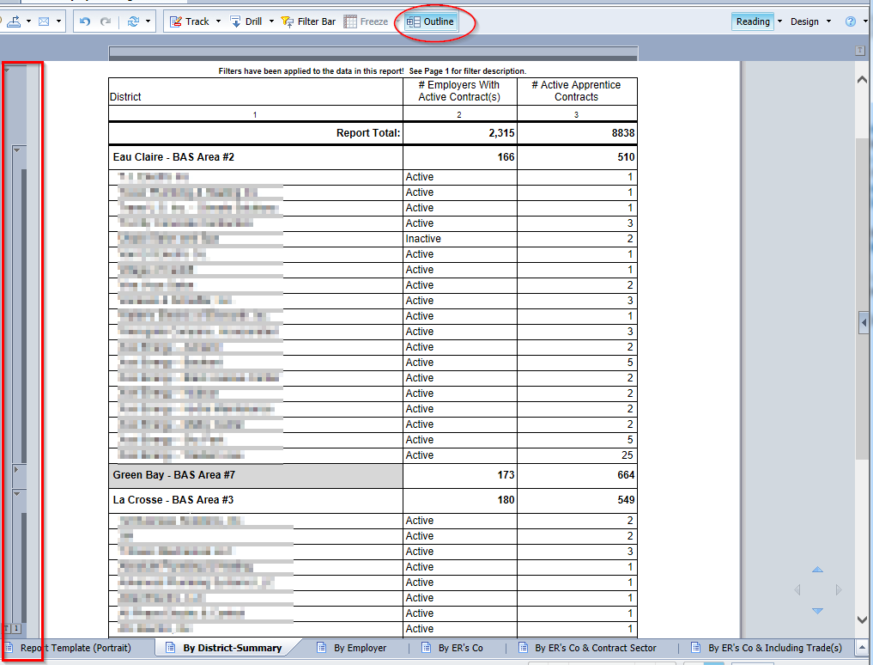

Arrows on the side allow you to expand/collapse individual sections. The outline level numbers at the bottom allow you to expand/collapse all items at that outline level.

Saving/Exporting/Printing Reports

The menu bas has options to Save, Print, export and send a report
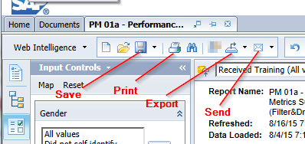

- Save – Click save to save the current version of the report. Click the dropdown arrow next to the icon to select Save As to save the report with a different name and/or location
- Print – Click to print the report.
- Export – Click export to export the reports data
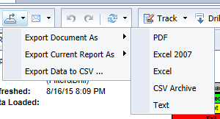.
Export Document As… exports all tab in the document, Export Report As … the current tab. Select the desired format for document/report and the report as displayed will be exported.
Export Data to CSV… will export the 'raw' results of the document's queries.
- Send – Click to send a report via email or to another Business Objects user
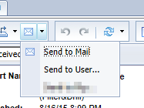

Send to Mail will display a dialog to enter e-mail information (to, from , subject, message, etc.)
Send to User.. will display a dialog allowing you to select a Business Objects user or group

Additional Information

Official Product Tutorials – SAP BusinessObjects BI Launch Pad 4.x – This is a SAP (the Business Objects vendor) web page containing interactive and video tutorials for using the BI Launch Pad to view and manage documents

Official Product Tutorials – SAP BusinessObjects Web Intelligence 4.x - This is a SAP (the Business Objects vendor) web page containing links to interactive and video tutorials for creating and modifying Web Intelligence documents. Some of these may be version specific. Our version is currently 4.1 SP5

