Department of Workforce Development
Worker’s Compensation Division
201 E. Washington Ave.
P.O. Box 7901
Madison, WI 53707
Telephone: (608) 266-1340
Fax: (608) 267-0394
https://dwd.wisconsin.gov/wc
e-mail: DWDDWC@dwd.wisconsin.gov
PHYSICIAN’S REPORT ON EYE INJURIES

Refer to Ind. 80.26, Loss of vision; determination

*Provision of your Social Security Number (SSN) is voluntary. Failure to provide it may result in an information processing delay.
The Department of Workforce Development (DWD) administers the Worker's Compensation Act, Chapter 102 Wis. Stats. The purpose of this form is to assist with the procurement of information related to or required by Chapter 102. Completion of this form is voluntary and failure to complete said form may result in a delay in the administration of Chapter 102. DWD may use the personally identifiable information (PII) it obtains from you on this form for purposes other than those for which it is being collected.
PATIENT | WC Claim Number |  |  | Employee Name
 | Social Security Number* |  |  | Employee Address
HISTORY | Injury Date |  |  | Employer Name |  |  |  |  |  | Insurance Company Name
 | Date of First Treatment |  |  |  |  | Date of Last Treatment or Exam |  |  |  |  |  |  | Which eye is injured?  Right Left Both
 | If only one eye is injured, is the other eye affected? Yes No If Yes, explain:
NATURE OF  INJURY  AND | Please be as detailed as possible
DIAGNOSIS | Is physical condition of the eyes stationary?  Yes No If No, explain:  Have all adequate and reasonable operations  been attempted? Yes No |  |  |  |  |  | - Did cataract form as a result of injury?  Yes No  - If cataract formed, was lens removed?  Yes No  3) Has there been a surgical implant of lens?  Yes No |  |  |  |  |  |  | Danger of further impairment?  Yes No  If Yes, explain:
CENTRAL  VISUAL  READINGS | Distance Use Snellen test letters or characters up to 20/800.  Near Use AMA Reading Card up to 14/560.
IMPORTANT: |  | After Injury |  |  |  |  |  |  | Pre-existing before injury, including presbyopia and other conditions clearly not the result of the injury.
PLEASE |  | Without Correction |  |  | With Correction |  |  |  | Without Correction |  |  |  |  |  |  | With Correction
FILL OUT |  | Distance | Near |  | Distance |  | Near |  | Distance |  |  | Near |  |  |  | Distance |  | Near
EACH LINE  COMPLETELY | Right |  |  |  |  |  |  | Right
FOR EACH EYE | Left |  |  |  |  |  |  | Left
PRIOR  DISABILITY | Did the employee wear glasses for pre-existing subnormal vision? Yes No  Is there a record or positive indication of pre-existing subnormal vision? Yes No If Yes, Explain:  Is the remaining impairment due to the injury? Yes No Explain:
BINOCULAR  VISION | Is there absence of useful binocular vision? Yes No  Explain cause:  If a result of the injury, what is the percentage of additional permanent disability? Industrial Motor Field Chart
Is there any diplopia present? Yes No

If Yes, this should be plotted in the chart at the right by placing an X in
each square in which diplopia is found. The test is to be made with any
industrially useful correction applied.

Was such correction used? Yes No

WKC-16-A-E (R. 09/2024)
FIELD Field vision taken without correction if possible using a white test object which subtends one degree and a standard
VISION perimeter with a radius of 12.9 inches (330 mm). The test object shall measure 0.223 inches (5.8 mm).
Is there any loss of the field of vision? Yes No Is it the result of the injury? Yes No
If so, indicate on the charts and table below. Sketch impaired area. Sketch areas of any scotomata.

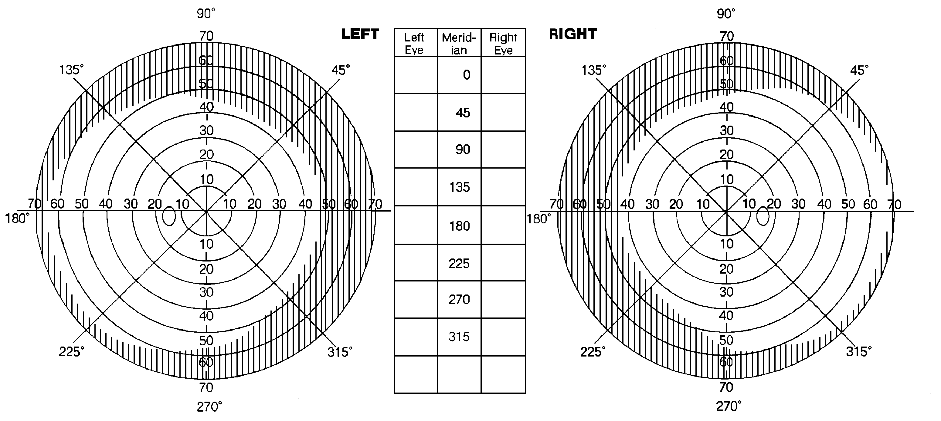

When did the last trace of inflammation disappear from the eye?

Date able to return to work:

_______________________________________________________________________________________
OTHER
FUNCTIONS Certain ocular disabilities are not covered in the foregoing sections, such as disturbance of accommodation, of color vision, of adaptation to light and dark, metamorphosia, entropion, ectropion, lagophthalmos, epiphora, and muscle disturbances not included under diplopia. Is any such disability present? If so, explain under “Remarks” below, stating whether it results from the injury, what it is, which eye, or whether both eyes are affected, and your percentage estimate of the impairment of the eye or eyes for industrial use.

Remarks:

Doctor Signature: _______________________________________________________ Date Signed:
(Required in doctor’s own handwriting)

Address:

