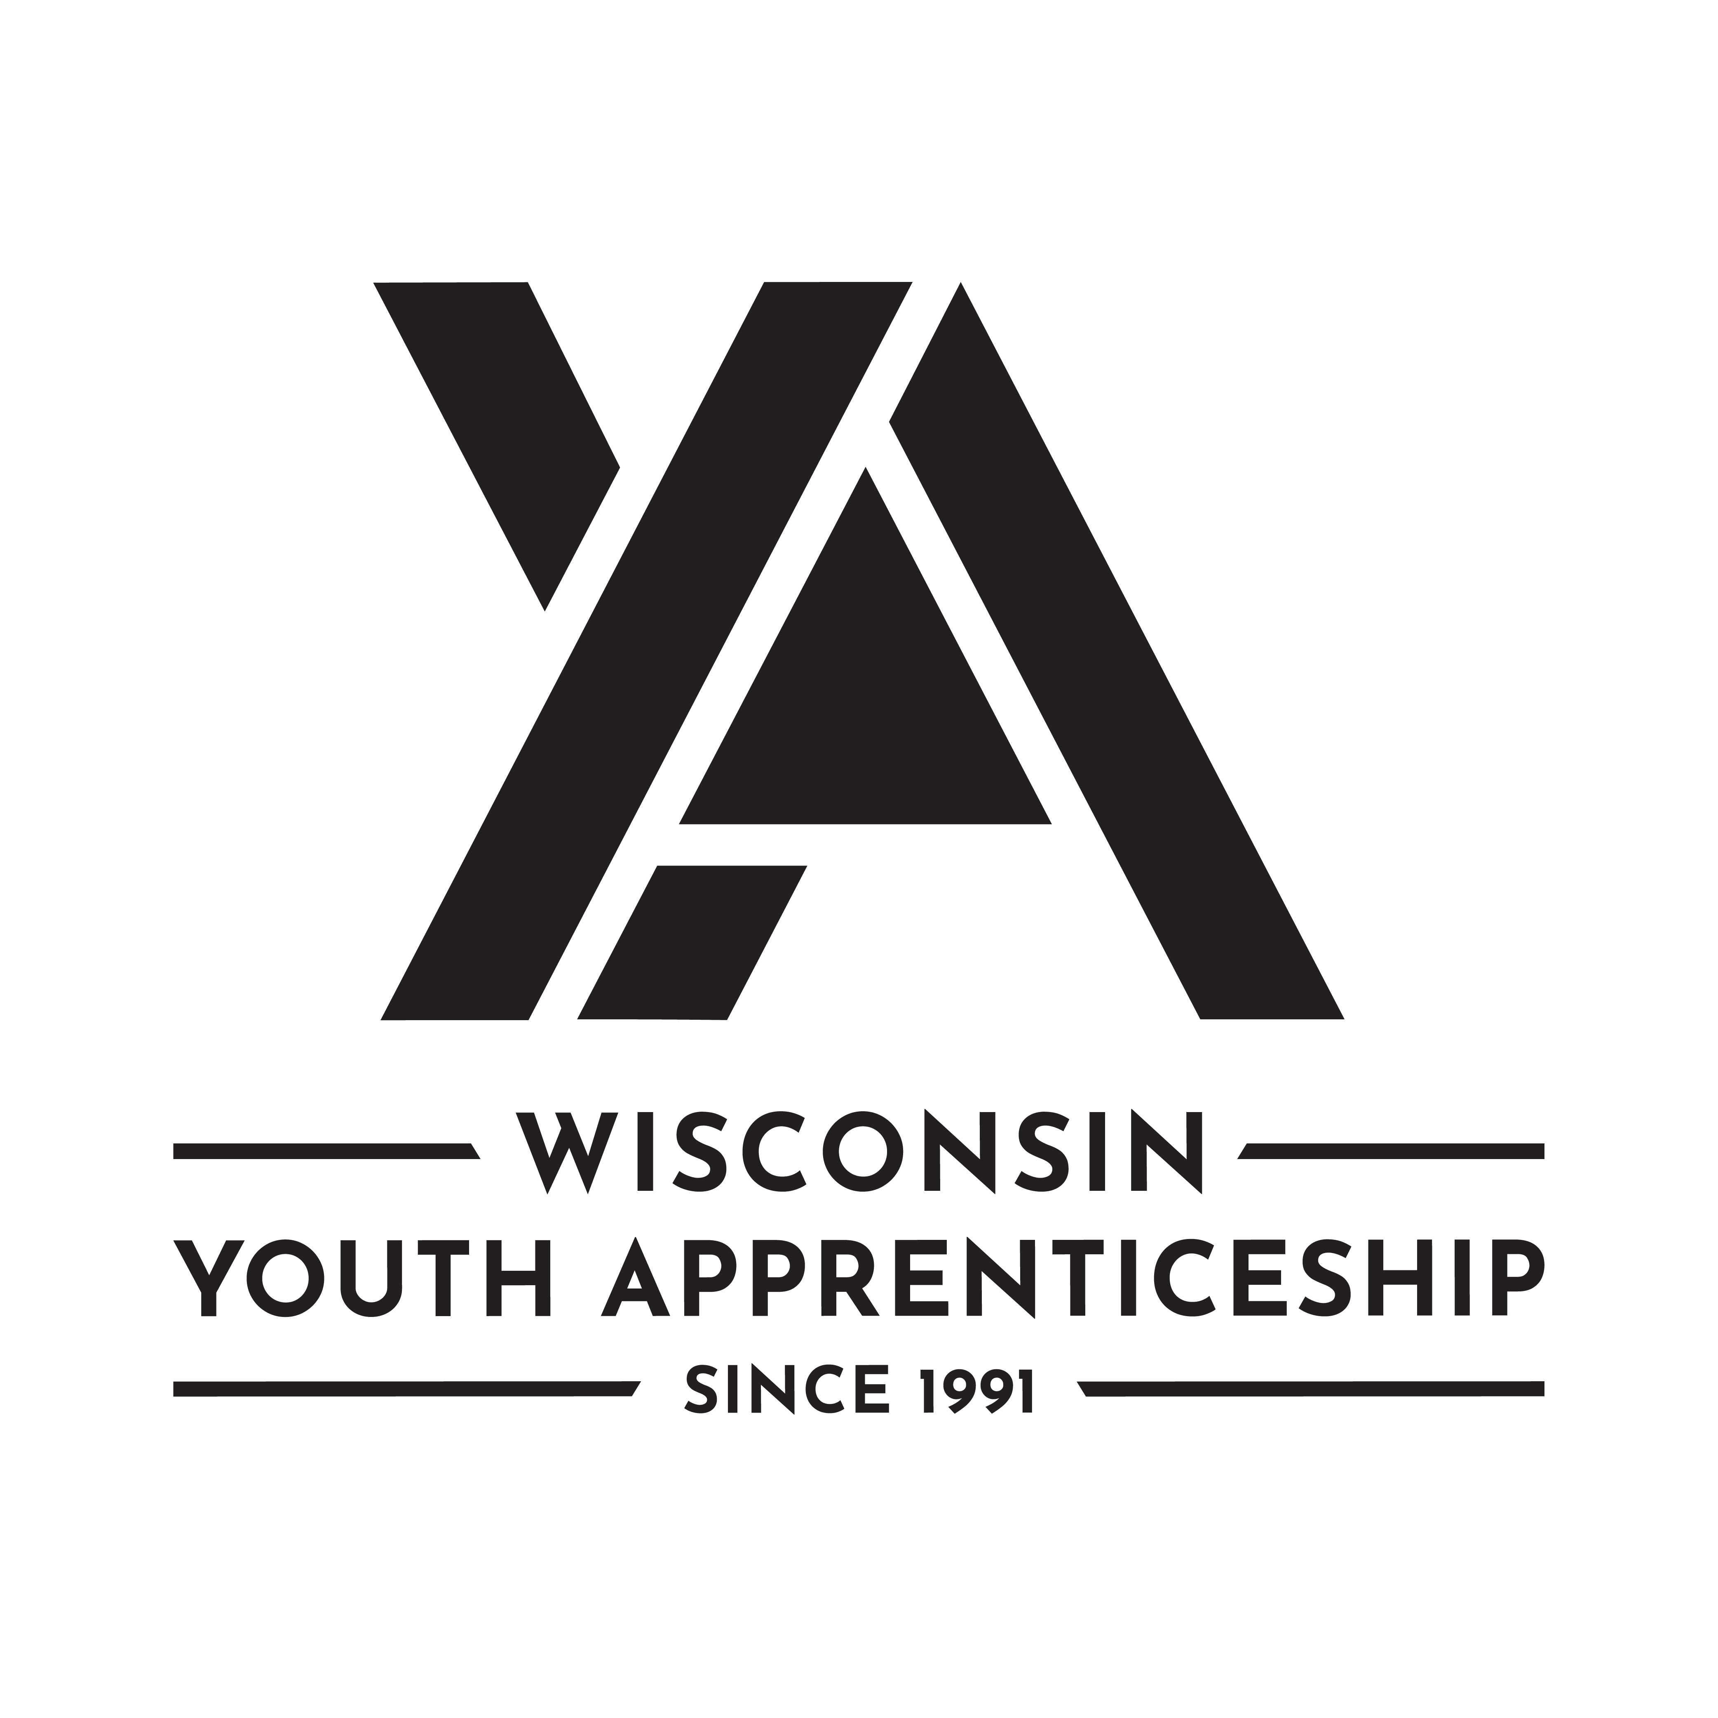 | Human Services Occupational Pathways  Youth Apprenticeship  Related Instruction Guide

Recommendations
These recommendations are intended to be used by the Youth Apprenticeship (YA) Consortia to determine appropriate related technical instruction for the YA programs in the Human Services occupational area. These recommendations are not all-inclusive.

Related Instruction Credits
The minimum number of related instruction credits for youth apprentices per year is indicated below. Youth apprentices may take more related instruction courses than the minimum required. No matter the options offered for the related instruction, youth apprenticeship students must receive high school credit toward graduation.
Options for related instruction include the following. Students must complete one of the options below.
Course Options | Minimum Number of Credits
High school course | 1 high school credit per year
College course | 3 college credits per year
Other options: employer provided training, online learning, independent study, etc. | 1 high school credit (options may be combined in various ways but must be equal to one high school credit—the student must receive high school credit toward graduation for this work)

Related Instruction options
Related instruction must be provided to all youth apprentices to support knowledge attainment necessary to master the competencies. Courses selected for related instruction should be aligned to the competencies identified in the program On-the-Job Learning (OJL) Performance Standards Guide.
Related courses can be drawn from a variety of options:
Type | Description
Registered Apprenticeship bridge courses | Youth apprentices may take courses that are part of the registered apprenticeship at local technical colleges or at other technical colleges online. These courses are excellent options for students because they provide a pathway for the student to seamlessly bridge into registered apprenticeship having completed some of the required coursework.

Type | Description
College transcripted/dual credit courses | Transcripted credit courses (also referred to as dual credit) provide an opportunity for the student to earn college credit directly from the college. Usually offered through the technical college, these courses may be taught by a technical college instructor or a high school instructor who holds an appropriate credential. Transcripted credit courses are good options because they allow students to earn credit toward a degree at the technical college or sometimes toward related instruction in a registered apprenticeship.
High school courses | High school courses that relate to the apprenticeship job competencies can be used for related instruction. Sometimes these courses can be articulated with the local technical college for advance standing. If the student goes on to take courses at the technical college, advance standing may be awarded for the course based on an articulation agreement between the high school and the college.
Other options | Other options to help students learn related instruction content include:  - Employer-provided training.  - Online courses provided by professional organizations.  - Independent study courses offered at the local high school.  These options can be combined in various ways provided they are related to the competencies in the OJL Performance Standards Guide and meet the minimum number of hours required for one high school credit.

Checklist for Course Selection
When choosing the courses for a youth apprenticeship using the competencies in the OJL Performance Standards Guide, consider these questions or refer to the decision flowchart.
Does the course bridge to a Registered Apprenticeship?
Does the course apply to a related college program?
Does the course qualify for dual credit?
Does the course qualify as a Perkins Pathway Career and Technical Education (CTE) course?
Is the course required for an occupation certification?

If YES to any above:
Is the course accessible to the student?
NOTE: Courses accessibility is determined by district or high school availability, transportation, course supply accessibility, course offering timeline and distance or virtual learning resources required.

If NO to any above, contact the Department of Workforce Development YA staff through the YA mailbox (ya@dwd.wisconsin.gov) to discuss options.
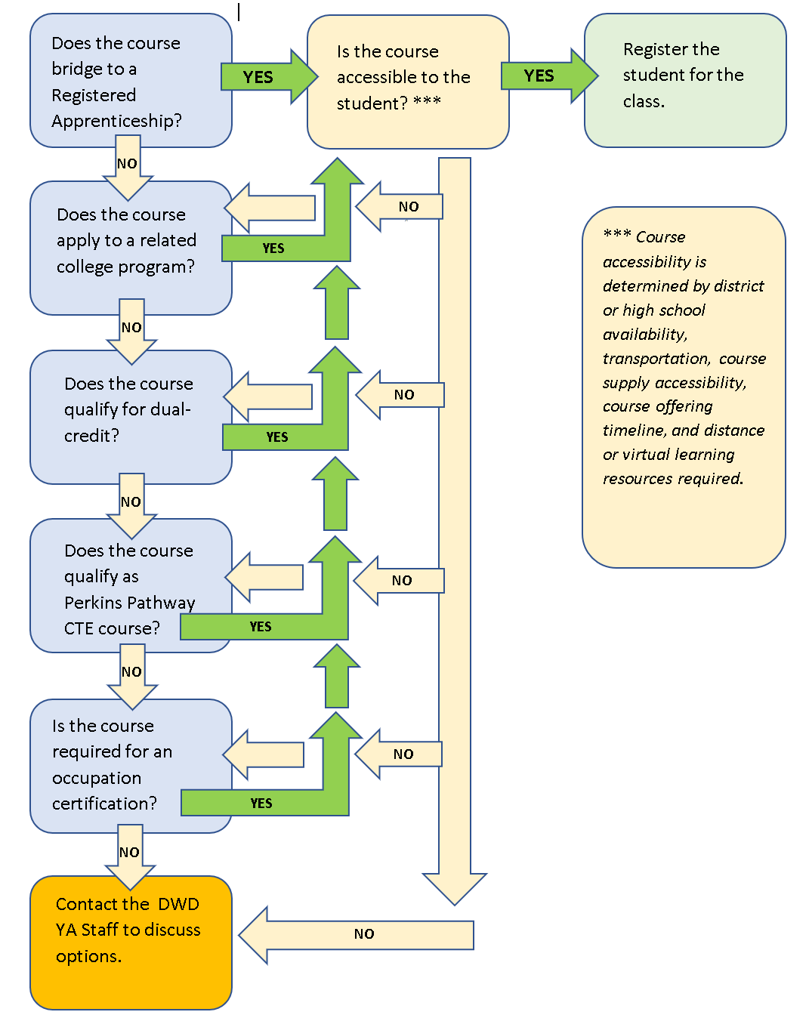

Opportunities for Registered Apprenticeship Bridge
Barber: Barbers cut, trim, shampoo, and style hair, trim beards, and give shaves. This is a one-year registered apprenticeship.
Cosmetologist: Cosmetologists provide beauty services, such as shampooing, cutting, coloring, and styling hair, and massaging and treating scalp. They may perform hair removal and provide nail and skin care services. This is a two-year registered apprenticeship.

Suggested Related Instruction Courses
The following courses are suggested as options for related instruction because they are aligned to the apprenticeship competencies in the OJL Performance Standards Guide. These recommendations are not all-inclusive.
Suggested Courses (titles are representative)
Course | Credits (College)
Customer Service/Business Communications | 1-3
Entrepreneurship | 3
Introduction to Business | 3
Introduction to Diversity Studies | 3
Marketing Principles | 3
Microsoft Office | 1-3
Oral/Interpersonal Communication | 3
Selling Principles | 3
Social Media Marketing | 3

Bridged Courses to Registered Apprenticeship

Cosmetologist
The following Wisconsin Technical College System courses bridge to the Cosmetologist Registered Apprenticeship.
Number | Title | Credits | Description
50-502-750 | Haircutting for Cosmetologists | .75 | Students will learn basic haircutting procedures to include disinfection and proper use of tools.
50-502-751 | Cosmetology Laws and Rules | .75 | Focuses on laws and rules affecting barber cosmetology in the state of Wisconsin.
50-502-752 | Professional Development for Cosmetologists | .5 | Examines the policies and responsibilities of the Barber/Cosmetology Program. Learners apply practices related to maintaining a healthy mind and body, and in determining personal qualities related to health and human relations. Also focuses on developing personal life management skills.
50-502-753 | Cosmetology Salon Ecology | .75 | Focuses on different types of organisms to prevent the spread of disease in a salon environment. Students explore basic safety and first aid methods in the salon.

Barber
The following Wisconsin Technical College System courses bridge to the Barber Registered Apprenticeship.
Number | Title | Credits | Description
50-502-596 | Shampooing, Trichology & Hairstyling for Barber Apprenticeship | 2 | This course provides apprentices with fundamental knowledge of hair care and develops skills required during draping, shampooing and scalp massage procedures. In addition, it examines the phases of hair growth, common hair disorders, and causes and treatments for hair loss. The final portion of the course explores hairstyling guidelines established by the Wisconsin Statutes and Administrative Codes for barbers.
50-502-597 | Barber Professional Development, Skin Disorders, Shaving and Male Facials, and Hair Cutting for Barber Apprenticeship | 2 | Apprentices will examine opportunities for lifelong learning and professional development. In addition, the course examines diseases and disorders of the skin, shaving, male facials, and hair cutting as mandated by the Wisconsin Statutes and Administrative Codes for the Barbering Examining Board.
50-502-598 | Barber Laws, Infection Control, and Chemical Texture Services for Barber Apprenticeship | 2 | Apprentices will examine the rules and regulations for barbers in Wisconsin. In addition, the course explores safety, sanitation, disinfection, and infection control practices and procedures that are common to all aspects of the barbershop and salon. Apprentices will also examine the theory and concepts surrounding chemical relaxing and permanent waving as mandated by the Wisconsin Statutes and Administrative Codes for the barbers.
50-502-599 | Hair Color, Lightening, Interpersonal Skills and State Codes for Barber Apprenticeship | 2 | Apprentices will examine the theory requirements for hair coloring and bleaching as mandated by the Wisconsin Statutes and Administrative Codes for the barbers. In addition, apprentices will develop fundamental skills needed to understand and communicate with people. A final review of the Wisconsin laws and administrative codes that govern the state barbers will be covered in preparation for state licensure exams.

This work is licensed under a Creative Commons Attribution-ShareAlike 4.0 International License.

This project is funded whole or in part by the Department of Labor, receiving Federal funding at $9 million which reflects 100% of the projects total budget.

This workforce product was funded by a grant awarded by the U.S. Department of Labor's Employment and Training Administration. The product was created by the recipient and does not necessarily reflect the official position of the U.S. Department of Labor. The Department of Labor makes no guarantees, warranties, or assurances of any kind, express or implied, with respect to such information, including any information on linked sites and including, but not limited to, accuracy of the information or its completeness, timeliness, usefulness, adequacy, continues availability or ownership.

No part of this document may be altered, duplicated, or extracted without written consent from the Wisconsin Department of Workforce Development (DWD).

DWD is an equal opportunity employer and service provider. If you have a disability and need assistance with this information, please dial 7-1-1 for Wisconsin Relay Service. Please contact the Division of Employment and Training at 888-258-9966 and press 6 to request information in an alternate format, including translated to another language.

